### Anvil Studio

Anvil Studio [1] was the software used to view and edit MIDI files. This software was used to validify the output of the *MIDI2Text* script in order to make sure script is converting the MIDI files to text as intended.

Anvil Studio was also used by the team to breakdown the MIDI files into constituent tracks that contained the different instruments which were used in the song, which played an important role in deciding which songs would be picked. It also allowed editing of the tracks, specifically changing the instrument that played each track which was used make the song sound like it was playing with the 4 instruments that we picked, considering how some songs used instruments that were similar to ours but sounded slightly different, like the glockenspiel used in a song as opposed to the xylophone that we picked.

Finally, the software was also used to edit the tracks to test instruments as well as to optimise the songs for the current orchestra.

### Music review

Musical notes are put into octaves which contain 8 notes. There are also 5 flats or sharps in an octave but the major scale goes from one C to the next C in the order C-D-E-F-G-A-B-C, where if the first C is C1 then last C would be C2 [2]. Every subsequent C has a frequency that is roughly double its predecessor. The progression of these Cs and their notations can be seen in Figure 1. More information on musical notes and scales can be found in the interim report (Section 3.9 of Appendix A)

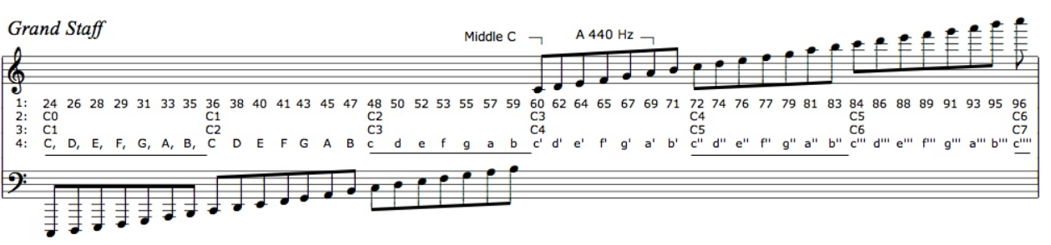

Figure . Musical notes according to MIDI and scientific notation [3].